**Industrial Traning Report**

**ON**

**“Portfolio”**

**Submitted by**

**Piyush Keshari (191500538)**

**Department of Computer Engineering & Applications**

**Institute of Engineering & Technology**



**GLA University**

**Mathura- 281406, INDIA**

**2020-2021**



**Department of computer Engineering and Applications**

**GLA University, Mathura**

**17 km. Stone NH#2, Mathura-Delhi Road, P.O. – Chaumuha,**

**Mathura – 281406**

**Declaration**

We hereby declare that the work which is being presented in the Fullstack Project “**PORTFOLIO”,** in partial fulfillment of the requirements for Fullstack Project viva voce, is an authentic record of our own work carried by the team members under the supervision of our mentor ***Mr. Pankaj Kapoor***.

Group Members: PIYUSH KESHARI (191500538)

Course: B.Tech (Computer Science and Engineering)

Year: 3rd

Semester: 5th

## Supervised by:

Mr. Pankaj Kapoor, Assistant Professor,

GLA University, Department of Computer Engineering & Application



**Department of computer Engineering and Applications**

**GLA University, Mathura**

**17 km. Stone NH#2, Mathura-Delhi Road, P.O. – Chaumuha,**

**Mathura – 281406**

**Certificate**

This is to certify that the above statements made by the candidates are correct to the best of my/our knowledge and belief.

_______________________

Supervisor

Mr. Pankaj Kapoor

Technical Trainer

Dept of CEA, GLA University

____________________ ____________________________ Project Coordinator Program Coordinator

(Mr. Mayank Srivastava) (Mr. Shashi Shekar)

**About the Project**

My project “PORTFOLIO” is a website for to showcase portfolio in a resoponsive web format which has beautiful UI.

**Motivation**

The motivation behind this project was given by my mentor and trainer ‘Angela Yu’, who came up with the idea of developing a website dedicated to showcase our projects through the mode of a website. There are few websites on internet based on same idea, but they lack the simple navigation/browsing which our website provides. This will also help me to showcase my work which might be useful at the times of placement because it provides one place to navigate all of my projects which I made during the college year.

**Requirements**

1. ***Software Requirements:***
2. Technology implemented: Fullstack (so far Frontend) Web Development.
3. Languages used: HTML, CSS, JavaScript.
4. IDE used: VS Code.
5. Web Browser: Google Chrome
6. Source Code: A repository is needed on ***Github***, to contain the project files.
7. Deployment: Github pages to deploy it live
8. ***Hardware Requirements:***
9. Processor: Intel i3
10. Operating System: Windows, MacOS, Linux
11. RAM: 4 GB
12. Devices: Desktop/Laptop
13. Hard Disk: 100 Mb

**Acknowledgment**

We thank the almighty for giving us the courage and perseverance in completing the project. We extend our sincere thanks to ***Mr. Pankaj Kapoor***, Assistant Professor at “GLA University, Mathura” for providing his valuable time and guidance at every stage of this project. We are profoundly grateful towards the unmatched services rendered by him. And last but not least, we would like to express our deep sense of gratitude and earnest thanksgiving to our dear parents for their moral support and heartfelt cooperation.

**Portfolio**

**Abstract**

My project “PORTFOLIO” is a website for to showcase portfolio in a resoponsive web format which has beautiful UI.

**Contents**

* About the project ………………….………………………………4
* Motivation…………………………………………………………5
* Requirements…………………………….......................................6
* Acknowledgment………………………………………………….7
* Abstract……………………………………………………………8
* Introduction……………………………………………………....10
* Technologies Used……………………………………………….11
* List of Figures………………………………………………...12-18
* Software Engineering………………………………………...19-22
* Conclusion……………………………………………………….24
* Bibliography……………………………………………………..25

**Introduction**

This website is developed on the Fullstack Web Development style. The frontend aspects of the website are developed using HTML, CSS and JavaScript.

The project folder contains html files, which contain html script with inline css. The files are further linked with separate css files and javascript files for styling/designing and functioning respectively. The website’s design is made responsive using media queries of css – the content is

So far only frontend has been developed. The backend will probably be developed using Node JS.

**Technologies Used**

HTML: The HyperText Markup Language, or HTML is the standard markup language for documents designed to be displayed in a web browser. HTML elements are delineated by tags, written using angle brackets. Tags such as <img/> and <input/> directly introduce content into the page. Browsers do not display the HTML tags, but use them to interpret the content of the page.

CSS: Cascading Style Sheets is a style sheet language used for describing the presentation of a document written in a markup language such as HTML. The name cascading comes from the specified priority scheme to determine which style rule applies if more than one rule matches a particular element. This cascading priority scheme is predictable.

JavaScript: JavaScript is the dominant client-side scripting language of the Web, with 97% of websites using it for this purpose. Scripts are embedded in or included from HTML documents and interact with the DOM. All major web browsers have a built-in JavaScript engine that executes the code on the user's device.

(When the backend development will start, it may use Node JS)

**List of Figures**

Home Page



About Us Page

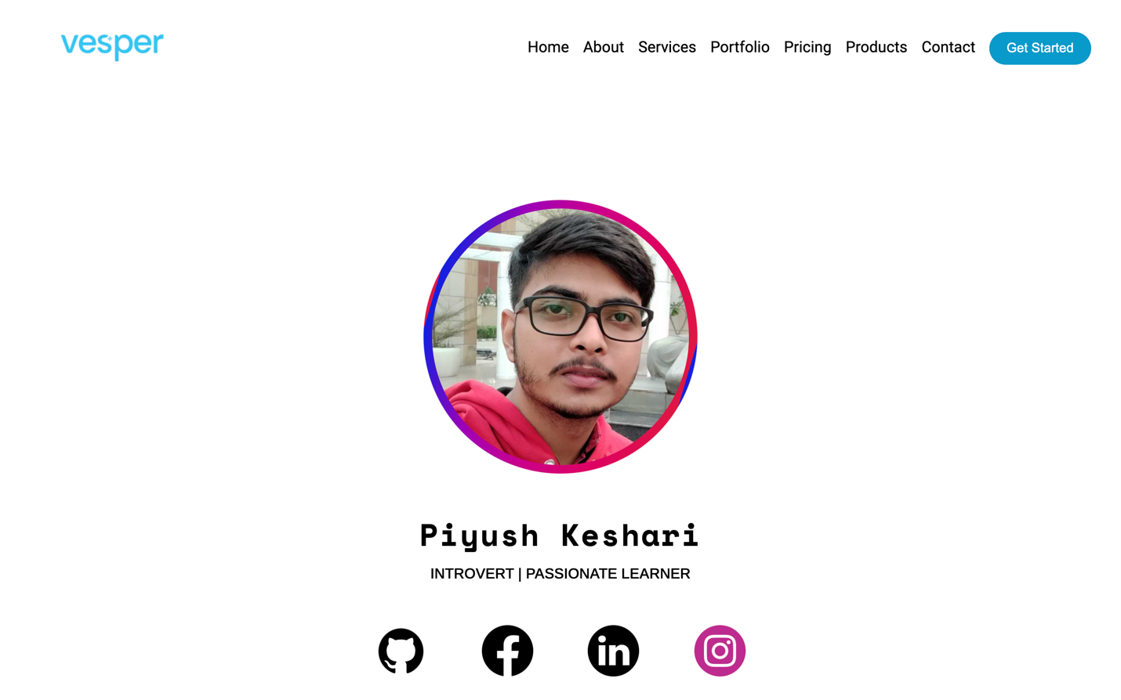

Contact Us Page

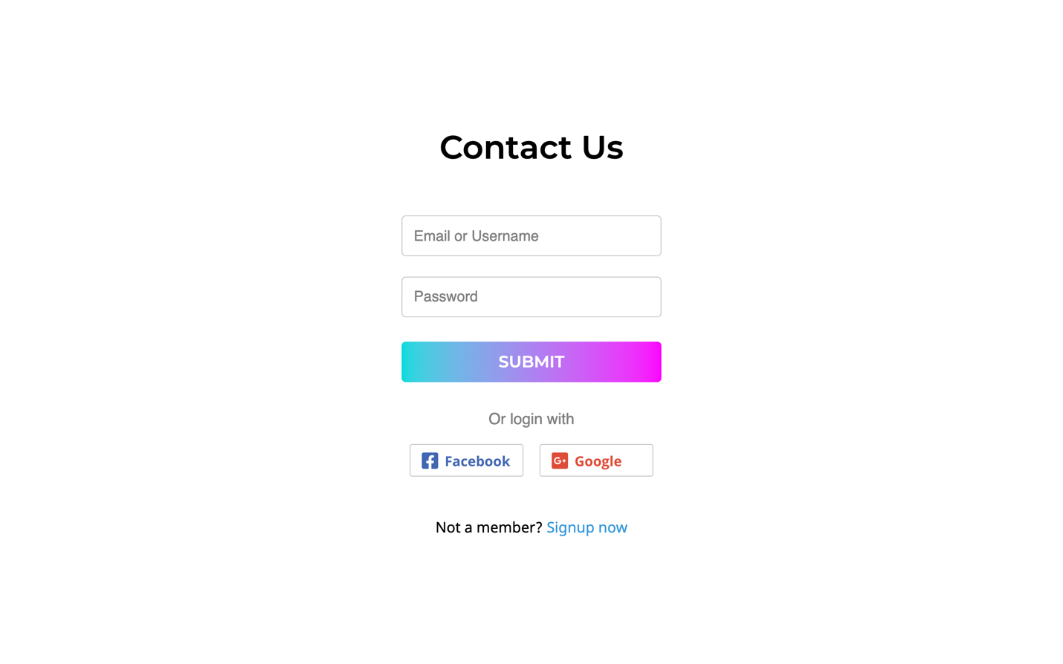

Navigation Bar



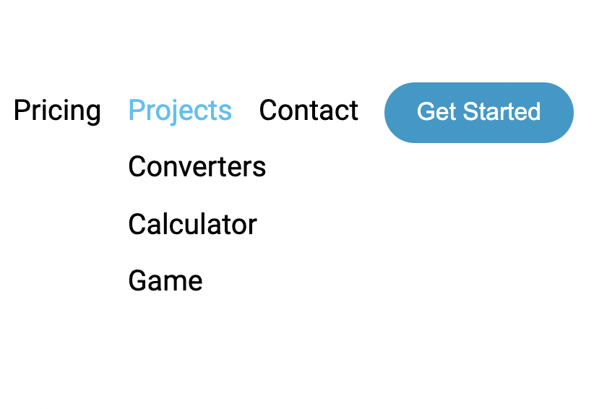

Calculator Project

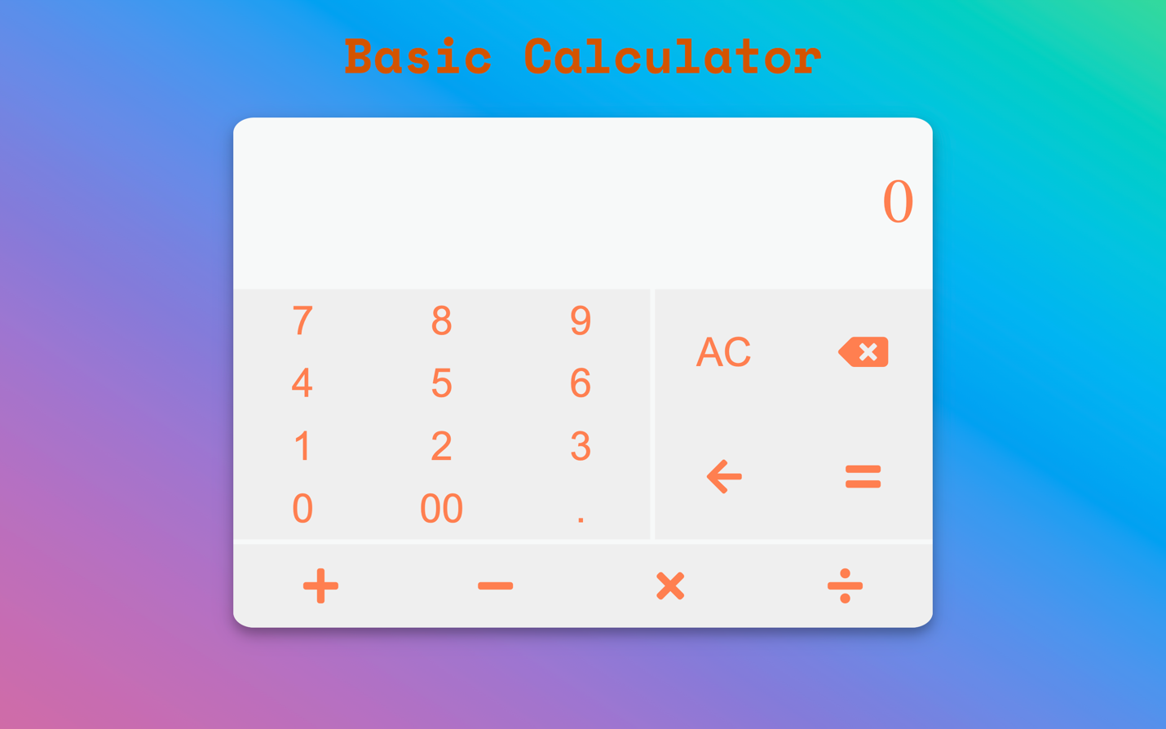

**Software Testing**

Once source code has been generated, software must be tested to uncover as many errors as possible before delivery. It is very important to work the system successfully and achieve high quality of software. Testing include designing a series of test cases that have a high likelihood of finding errors by applying software-testing techniques. System testing makes logical assumptions that if all the parts of the system are correct, the goal will be successfully achieved. The system should be checked logically. Validations and cross checks should be there. Avoid duplications of record that cause redundancy of data. In other Words, Testing is the process of evaluating a system or its component(s) with the intent to find whether it satisfies the specified requirements or not. It is executing a system in order to identify any gaps, errors, or missing requirements in contrary to the actual requirements.

The preliminary goal of implementation is to write source code and internal documentation so that conformance of the code to its specifications can be easily verified, and so that debugging, testing and modifications are eased. This goal can be achieved by making the source code as clear and straightforward as possible. Simplicity, clarity and

elegance are the hallmark of good programs, obscurity, cleverness, and complexity are indications of inadequate design and misdirected thinking. Source code clarity is enhanced by structured coding techniques, by good coding style, by, appropriate supporting documents, by good internal comments, and by feature provided in modern programming languages. The implementation team should be provided with a well-defined set of software requirement, an architectural design specification, and a detailed design description. Each team member must understand the objectives of implementation.

**4.1 TERMINOLOGY**

Error The term error is used in two ways. It refers to the difference between the actual output of software and the correct output, in this interpretation, error is essential a measure of the difference between actual and ideal. Error is also to used to refer to human action that result in software containing a defect or fault.

Fault is a condition that causes to fail in performing its required function. A fault is a basic reason for software malfunction and is synonymous with the commonly used term Bug.

Failure is the inability of a system or component to perform a required function according to its specifications. A software failure occurs if the behavior of the software is the different from the specified behavior. Failure may be caused due to functional or performance reasons.

**4.2 TYPES OF TESTING**

**a. Unit Testing** The term unit testing comprises the sets of tests performed by an individual programmer prior to integration of the unit into a larger system. A program unit is usually small enough that the programmer who developed it can test it in great detail, and certainly in greater detail than will be possible when the unit is integrated into an evolving software product. In the unit testing the programs are tested separately, independent of each other. Since the check is done at the program level, it is also called program teasing.

**b. Module Testing** A module and encapsulates related component. So can be tested without other system module.

**c. Subsystem Testing** Subsystem testing may be independently design and implemented common problems are sub-system interface mistake in this checking we concenton it. There are four categories of tests that a programmer will typically perform on a program unit.

i Functional test

ii Performance test

iii Stress test

iv Structure test

**Functional Test** Functional test cases involve exercising the code with Nominal input values for which expected results are known; as well as boundary values (minimum values, maximum values and values on and just outside the functional boundaries) and special values.

**Performance Test** Performance testing determines the amount of execution time spent in various parts of the unit, program throughput, response time, and device utilization by the program unit. A certain amount of avoid expending too much effort on fine-tuning of a program unit that contributes little to the overall performance of the entire system. Performance testing is most productive at the subsystem and system levels.

**Stress Test** Stress test are those designed to intentionally break the unit. A great deal can be learned about the strengths and limitations of a program by examining the manner in which a program unit breaks.

**Structure Test** Structure tests are concerned with exercising the internal logic of a program and traversing particular execution paths. Some authors refer collectively to functional performance and stress testing as “black box” testing. While structure testing is referred to as “white box” or “glass box” testing. The major activities in structural testing are deciding which path to exercise, deriving test date to exercise those paths, determining the test coverage criterion to be used, executing the test, and measuring the test coverage achieved when the test cases are exercised.

**Conclusion**

We have completed our project within time limit with the coordination of our team members under the supervision of our mentor Mr. Pankaj Kapoor.

Our project repository is available at

Our deployment is available at

**Bibliography**

<https://www.geeksforgeeks.org/>

<https://www.wikipedia.org/>

<http://svgicons.sparkk.fr/>

<https://www.iconfinder.com/>

<https://www.beta-labs.in/>

<https://www.tutorialspoint.com/index.htm>